**Solapur Education Society’s Polytechnic**

Solapur -413002



**CERTIFICATE**

This is to certify that

Viresh Kamlapure 3506

Sahil Chouhan 3507

Komal Kudal 3556

Mrudula Sadafule 3548

Of **6I** Semester of Diploma in **Computer Technology** of Institute **Solapur Education Society’s Polytechnic, Solapur (0095)** has satisfactorily completed micro-project titled  **Notepad Using Python Tkinter** in course **Programming With Python(22616)** for academic year 2022-23 as prescribed in curriculum by Maharashtra State Board of Technical Education, Mumbai.

Place :-Solapur

Date :

**Course In-charge HOD Principal**

Mrs. Rajmane S.S. M.C. Patil A.A.Bhawtankar

**Solapur Education Society’s Polytechnic**

Solapur -413002



**CERTIFICATE**

This is to certify that Mr./Ms. **________________________________** Roll No. ___Of **6I** Semester of Diploma in **Computer Technology** of Institute **Solapur Education Society’s Polytechnic, Solapur (0095)** has satisfactorily completed micro-project titled  **Notepad Using Python Tkinter** in course **Programming With Python(22616)** for academic year 2022-23 as prescribed in curriculum by Maharashtra State Board of Technical Education, Mumbai.

Place :-Solapur Enrollment No :-

Date : Exam Seat No :-

**Course In-charge HOD Principal**

Mrs. Rajmane S.S. M.C. Patil A.A.Bhawtankar

**Solapur Education Society’s Polytechnic**

Solapur -413002



**Micro Project- Report**

**Program :- Computer Technology**

**Course (Code) :- Programming With Python(22616)**

**Academic Year :- 2022-23 Semester/Scheme:- 6I**

**Title :- Notepad Using Python Tkinter**

**Name of the Teacher: Ms. S.S.Rajmane**

**Group Members:- Roll no.**

**1**. Viresh Kamlapure 3506

2. Sahil Chouhan 3507

3. Komal Kudal 3556

4. Mrudula Sadafule 3548

**Solapur Education Society’s Polytechnic**

**Program: - Computer Technology**

**ANNEXURE I**

**Rubric for Evaluation of Micro Project**

**Title of Micro Project: Notepad Using Python Tkinter**

**Group Members: Viresh Kamlapure , Sahil Chouhan ,Komal Kudal ,Mrudula Sadafule**

|  |  |
| --- | --- |
| **Name** | **Roll No** |
| Viresh Kamlapure | **3506** |
| Sahil Chouhan | **3507** |
| Komal Kudal | **3556** |
| Mrudula Sadafule | **3548** |

|  |  |  |  |  |  |
| --- | --- | --- | --- | --- | --- |
| **Sr. No** | **Criteria** | **Marks Obtained (Out of 2)** | **Indicators for different level of Performance**  **(Evaluation Scale 0 to 2)** | | |
| **Poor (0)** | **Average (1)** | **Good (2)** |
| **1** | Submission of Project proposal/Report |  | Not Submitted anything in time | proposal or project report submitted in time | Project proposal & project report submitted ij time |
| **2** | CO/Microproject mapping |  | Not attained any CO/Micro.Pro. | Attained some CO/ Micro.Pro. | Attained maximum CO/ Micro.Pro. |
| **3** | Content of project/Formatting |  | Not contains relevant information | Contains some relevant information | Contains maximum relevant information |
| **4** | **Total Marks (06)** |  |  | | |
| **5** | **Question/ Answers (04)** |  |  | | |
| **Out of (10)** | |  |  | | |

**Name & Sign of Teacher**

**Solapur Education Society’s Polytechnic**

**Program: - Computer Technology**

**CO/Microproject mapping**

**Academic Year- 2022-23 Class: - CM6I Course: Programming With Python**

**Roll No: 3506,3507,3556,3548 Exam Seat No: 179451,179443,179470,179494**

|  |  |
| --- | --- |
| **CO1** | Display message on screen using python script. |
| **CO2** | Develop Python program to demonstrate use of operators. |
| **CO3** | Perform operations on data structures. |
| **CO4** | Develop functions for given problems. |
| **CO5** | Design classes for given problems. |
| **CO6** | Handle Exceptions. |

**Mark Levels (1,2,3) on following table as per Title of Micro Project**

**1: Low, 2: Medium, 3: High**

|  |  |  |  |  |  |  |
| --- | --- | --- | --- | --- | --- | --- |
| **Title of Micro Project** | **CO1** | **CO2** | **CO3** | **CO4** | **CO5** | **CO6** |
| **[ microproject title ]** | **1** | **2** | **2** | **2** | **-** | 3 |

**\*put – (dash) if cannot mapped with CO**

**Sign of Teacher**

**Introduction:**

**Write what your project does?**

This project is a basic text editor using the tkinter library in Python. The program creates a graphical user interface that allows users to create, open, save, and edit text files. The main functionality of the program includes opening a new file, opening an existing file, saving the current file, saving the file as a new file, cutting, copying, and pasting text, and quitting the application. The program also provides a menu bar that includes options for file, edit,and help. . Additionally, the program includes an "about" box that displays information about the developer of the program.

**Write brief introduction to contents of python used in your project.**

The project is a simple implementation of a text editor using Python's tkinter library. It consists of various functions such as creating a new file, opening an existing file, saving a file, saving a file with a new name, copying, cutting and pasting text, and displaying information about the application.

In terms of Python concepts, the project uses functions, conditionals, loops, and file handling. The Tkinter module is used for creating the graphical user interface (GUI) of the application, which includes the main window, text area, menus, and dialog boxes. The project also makes use of some OS-specific functions such as os.path.basename() for obtaining the filename from a given path and os.close() for closing a file. Overall, the project demonstrates how to create a simple GUI application using Python's built-in libraries.

**Program Code:**

from tkinter import *

from tkinter import messagebox

from tkinter.messagebox import showinfo

from tkinter.filedialog import askopenfilename,asksaveasfilename

import os

def newFile():

global file

file = TextArea.get(1.0,END)

if not file.strip():

root.title("Untitled - Notepad")

file = None

TextArea.delete(1.0 ,END)

else:

result = messagebox.askyesnocancel("Save Dialog Box","Do you want to save your file")

if result==True:

file = asksaveasfilename(defaultextension = '.txt',filetypes=[('Text File','*.txt'),('All files','*.*')])

f = open(file,"w")

f.write(TextArea.get(1.0,END))

root.title("Untitled - Notepad")

TextArea.delete(1.0,END)

elif result==False:

root.title("Untitled - Notepad")

TextArea.delete(1.0,END)

#delete function will delete data from first line zero character to end of file

def openFile():

global file

file = askopenfilename(defaultextension=".txt",filetypes=[("All Files" , "*.*" ),("Text Documents","*.txt")])

if file == "":

file = None

else:

root.title(os.path.basename(file) + " - Notepad")

TextArea.delete(1.0,END)

f = open(file,"r")

TextArea.insert(1.0,f.read())

f.close()

print("File Opened")

def saveFile():

global file

if (file==None):

file = asksaveasfilename(initialfile='Untitled.txt',defaultextension=".txt",filetypes=[("All Files" , "*.*" ),("Text Documents","*.txt")])

if(file==""):

file=None

else:

#Save as a new file

f = open(file,"w")

f.write(TextArea.get(1.0,END))

f.close()

root.title(os.path.basename(file)+ " - Notepad")

print("File Saved")

else:

#save the file

f = open(file,"w")

f.write(TextArea.get(1.0,END))

f.close()

print("Existing File Saved")

def saveFileAs():

global file

file = asksaveasfilename(defaultextension = '.txt',filetypes=[('Text File','*.txt'),('All files','*.*')])

f = open(file,"w")

f.write(TextArea.get(1.0,END))

root.title(os.path.basename(file)+ " - Notepad")

print("File Saved-AS")

f.close()

def quitApp():

file = TextArea.get(1.0,END)

if not file.strip():

quit()

else:

result = messagebox.askyesnocancel("Save Dialog Box","Do you want to save your file")

if result==True:

file = asksaveasfilename(defaultextension = '.txt',filetypes=[('Text File','*.txt'),('All files','*.*')])

f = open(file,"w")

f.write(TextArea.get(1.0,END))

root.title(os.path.basename(file)+ " - Notepad")

elif result==False:

quit()

def cut():

TextArea.event_generate(("<<Cut>>"))

def copy():

TextArea.event_generate(("<<Copy>>"))

def paste():

TextArea.event_generate(("<<Paste>>"))

def about():

showinfo("Notepad","Notepad by Viresh Kamlapure \n Its PWP microproject")

if __name__ == '__main__':

#Basic tkinter setup

root = Tk()

root.title("Untitled - Notepad")

root.wm_iconbitmap("1.ico")

root.geometry("500x488")

#Add TextArea

TextArea = Text(root,font="lucida 13 ")

file = None

TextArea.pack(expand=True,fill=BOTH)

#Menubar

MenuBar = Menu(root)

#File Menu starts

FileMenu = Menu(MenuBar,tearoff=0)

# For open new file

FileMenu.add_command(label="New",command=newFile)

#For open aldready existing file

FileMenu.add_command(label="Open",command=openFile)

# For save the current file

FileMenu.add_command(label="Save",command=saveFile)

# For save the current file

FileMenu.add_command(label="Save As",command=saveFileAs)

FileMenu.add_separator()

#For quit app

FileMenu.add_command(label="Exit",command= quitApp)

MenuBar.add_cascade(label="File",menu=FileMenu)

#File Menu Ends

#Edit Menu starts

EditMenu = Menu(MenuBar,tearoff=0)

#For feature of cut, copy , paste

EditMenu.add_command(label="Cut",command=cut)

EditMenu.add_command(label="Copy",command=copy)

EditMenu.add_command(label="Paste",command=paste)

MenuBar.add_cascade(label="Edit",menu=EditMenu)

#Edit Menu Ends

#Help Menu starts

HelpMenu = Menu(MenuBar,tearoff=0)

HelpMenu.add_command(label="About Notepad",command=about)

MenuBar.add_cascade(label="Help",menu=HelpMenu)

#Help Menu ends

root.config(menu=MenuBar)

#Adding Scrollbar

Scroll = Scrollbar(TextArea)

Scroll.pack(side=RIGHT,fill=Y)

Scroll.config(command=TextArea.yview)

TextArea.config(yscrollcommand=Scroll.set)

root.mainloop()

**Output(screen shot):**

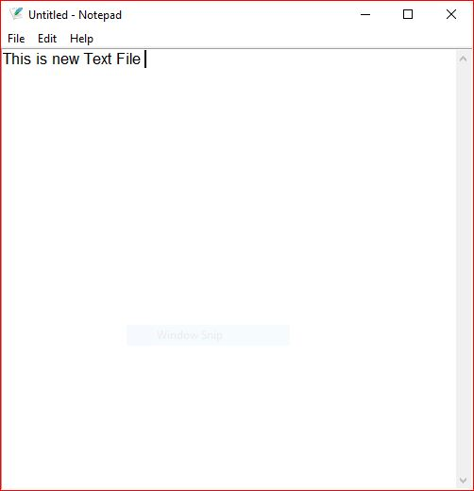

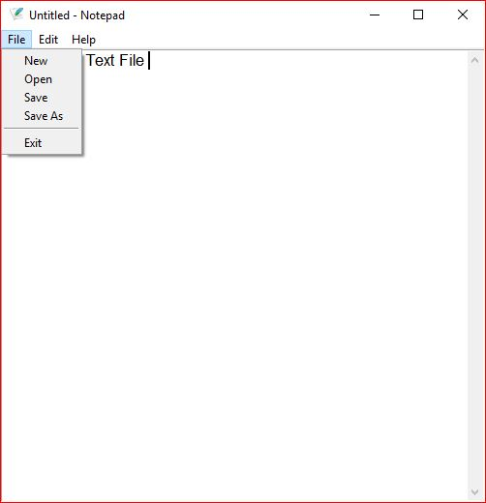

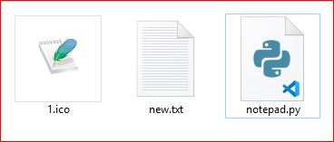

**REFERENCES :**